CHAPTER 1
INTRODUCTION
1.1 Background of the Study
MedXNet – AI-Based Multi-Disease Classification System, plays a fundamental role in diagnosing respiratory and infectious diseases such as Pneumonia, Tuberculosis, COVID-19, and other pulmonary abnormalities. Chest radiography is one of the most widely used diagnostic tools because of its affordability, high availability, and ability to capture crucial information for clinical decision-making. However, interpreting chest X-rays requires trained radiologists, and misdiagnosis may occur due to factors such as excessive workload, fatigue, lack of specialists, and the presence of subtle radiological patterns that are difficult to detect through visual inspection alone.
Respiratory diseases remain a major global health concern. Conditions such as pneumonia, tuberculosis, emphysema, asthma, COVID-19, and lung malignancies cause significant morbidity and mortality worldwide. Many lung diseases share symptoms similar to common flu or fever, making early detection challenging without imaging. Since approximately 2 million chest radiographs are performed worldwide every year, computer-assisted diagnosis has become an essential tool, especially in clinical environments with a shortage of expert medical staff.
1.2 Need for Intelligent Diagnostic Systems
Manual interpretation of X-rays is prone to human limitations, whereas modern AI models—especially deep learning architectures—have demonstrated diagnostic accuracy comparable to expert radiologists. Automated disease classification systems can support healthcare professionals by providing fast, reliable, and objective analysis, while reducing diagnostic delays and error rates. Such solutions are particularly beneficial for rural hospitals, emergency units, telemedicine setups, and regions with limited availability of radiologists.
A versatile and efficient system capable of identifying multiple lung diseases with high precision is therefore crucial. While earlier research explored deep CNN architectures (VGG16, DenseNet, ResNet, Xception, InceptionV3, EfficientNet) and even GAN-based augmentation techniques, there remains a need for a lightweight, real-time, and deployable model tailored for practical medical environments.

1.3 Project Overview – MedVisionX
MedXNet – AI-Based Multi-Disease Classification System is an AI-powered lung disease classification system designed to automate the analysis of chest X-ray images. The system focuses on four major classes:
- Normal
- Pneumonia
- Tuberculosis
- COVID-19
The model is trained on a Kaggle chest X-ray dataset containing approximately 2000 labeled images, divided into nearly equal training and testing subsets.
1.4 Deep Learning Approach and Model Selection
Several deep learning models were explored in the literature for CXR classification. However, MobileNetV2 was chosen for MedXNet because of the following strengths:
- Lightweight architecture suitable for mobile and edge devices
- Depthwise separable convolutions for faster computation
- Inverted residual blocks improving feature extraction
- High accuracy with low resource usage
- Ideal for real-time deployment in healthcare settings
The training pipeline includes resizing images to 224×224, normalization, data augmentation, and fine-tuning MobileNetV2 on the target dataset. The model demonstrated strong generalization with an accuracy of 94–96% across all four classes.

1.5 System Implementation and Features
To ensure usability in real-world healthcare environments, MedVisionX integrates a user-friendly application developed in Streamlit, featuring:
- Intuitive drag-and-drop X-ray upload
- Real-time prediction and confidence visualization
- Detailed probability bar charts for interpretability
- Lightweight local JSON-based history storage
- Thumbnail previews of previously analyzed images
- Options to delete individual records or clear the entire history
- Zero dependence on external databases
The combination of AI-driven prediction and an accessible interface enables clinicians to quickly assess respiratory conditions, improving triage decisions and diagnostic efficiency.

1.6 Contribution to Healthcare
MedXNet contributes significantly to the field of AI-assisted diagnostics by:
- Providing fast, reliable disease detection in under-resourced medical settings
- Reducing the burden on radiologists
- Supporting early diagnosis—critical for diseases like TB and pneumonia
- Enabling telemedicine and remote consultations
- Offering a scalable foundation for future enhancements such as:
  - Lung cancer detection
  - Transformer-based architectures (ViT, Swin Transformer)

  - Grad-CAM explainability
  - Cloud deployment and multi-user access

1.7 Summary
In summary, MedXNet addresses a crucial medical need by combining deep learning, transfer learning, and an efficient deployment framework to support chest disease classification. The system demonstrates that AI can play a transformative role in assisting radiologists, improving diagnostic accuracy, and expanding access to quality healthcare.

CHAPTER 2

LITERATURE SURVEY

2.1 Introduction
MedXNet AI-Based Multi-Disease Classification System has been a major area of research due to the global burden of respiratory diseases such as Pneumonia, Tuberculosis, COVID-19, lung cancer, and other pulmonary abnormalities. Early detection greatly improves treatment outcomes; however, manual interpretation of radiographs requires expert radiologists and is prone to human limitations such as fatigue, workload stress, and subjective variation.
The rapid evolution of Artificial Intelligence (AI), particularly Deep Learning and Convolutional Neural Networks (CNNs), has enabled automated diagnostic systems that achieve expert-level accuracy. This chapter reviews relevant literature on deep learning models used for lung disease classification, multi-label diagnosis, lightweight architectures, and techniques for dataset augmentation.
2.2 Convolutional Neural Networks (CNNs) in Medical Imaging
CNNs are widely adopted for classification and segmentation tasks in medical imaging. They automatically learn spatial features such as edges, textures, and lung opacities—making them suitable for identifying thoracic pathologies.
Rajpurkar as introduced CheXNeXt, a CNN trained on the ChestX-ray14 dataset containing 112,120 radiographs. Their model achieved performance comparable to radiologists in detecting 14 diseases simultaneously. Using AUC as the evaluation metric, CheXNeXt outperformed radiologists in Atelectasis detection, achieving an AUC of 86.2% compared to 80.8% by humans.
Limitations:
- Dataset collected from a single medical center
- No use of patient history
- Model required heavy computational resources

2.3 MobileNet and Lightweight Networks
Lightweight networks have gained attention due to their suitability for deployment in resource-constrained healthcare environments.
Souid et al. proposed a MobileNetV2-based classification system for the NIH ChestX-ray14 dataset. Due to significant class imbalance, resampling and augmentation techniques were applied. With 10 epochs and batch size 32, the model achieved:
- 90% accuracy
- 0.45 sensitivity
- 0.97 specificity
- 0.55 F1-score
MobileNet’sdepthwise separable convolutions make it ideal for IoT devices and local hospital machines.
Hu et al. further introduced MD-Conv, using multi-scale depthwise convolutions to capture variable tissue structures. Although AUC was moderate (~0.78), computational efficiency improved significantly.
2.4 DenseNet-Based Approaches
DenseNet architectures connect each layer to every other layer, allowing better feature reuse and improved gradient flow.
Siemens et al. proposed DNetLoc, using high-resolution X-rays (1024×1024) to preserve maximum anatomical detail. Using a combined ChestX-ray14 + PLCO dataset with 297,541 images, the model achieved AUC values of:
- 0.84 (ChestX-ray14)
- 0.87 (PLCO)
DenseNet-based solutions are powerful but computationally expensive, limiting their use in real-time clinical deployment.

2.5 VGG-Based Hybrid Models
Bharati et al. developed VDSNet, a hybrid architecture combining VGG with Spatial Transformer Networks (STN). Trained on the NIH Chest X-ray dataset, the model achieved:
- 73% validation accuracy, outperforming VGG, hybrid CNN, and capsule networks
However, VGG models are deep and require high computational power, making them unsuitable for low-resource environments.
2.6 ResNet-50 and Transfer Learning Approaches
ResNet-50, with its skip connections, addresses vanishing gradient issues and offers strong performance for classification tasks.
Baltruschat et al. evaluated ResNet-50 with transfer learning and feature incorporation (age, gender, etc.). Class-balanced binary cross-entropy was used, achieving:
- AUC improvement from 0.73 to 0.80
- Enhanced performance when non-image metadata was included
This showed that transfer learning significantly improves model generalization.
2.7 Multi-Label Disease Classification
Several authors emphasize multi-label classification, where a single X-ray may exhibit multiple co-occurring pathologies.
Pillai et al. trained models including DenseNet121, ResNet-50, and InceptionV3 on the CheXpert dataset (14 labels).
Results included:
- AUROC up to 78%
- Training accuracy around 87%
- Accurate detection even with overlapping abnormalities
Multi-label classification aligns closely with real-world medical scenarios.

However, MedXNet currently uses single-label classification (Normal, Pneumonia, TB, COVID-19).
2.8 GAN-Based Synthetic Data Generation
To address class imbalance, many studies explore Generative Adversarial Networks (GANs) for creating synthetic X-ray images.
Motamed et al. used GANs to augment datasets for pneumonia and COVID-19. Their model achieved:
- Sensitivity = 0.82, Accuracy = 0.80 (Dataset I)
- Improved class balancing and feature diversity
Malygina et al. applied GAN-generated samples to improve AUC in pneumonia recognition from 0.9745 to 0.9929.
GANs improve dataset quality but require careful tuning and high computational cost.
MedXNet does not use GANs but relies on optimized augmentation and MobileNetV2 for balanced performance
2.9 Additional Approaches in Literature
Other notable contributions include:
- Multi-source federated learning for privacy-preserving classification (Priya et al.)
- Custom CNNs + AlexNet + VGG16 for mixed CT/X-ray datasets (Al-Sheikh et al.)
- Two-stage GAN + segmentation networks for improved lung boundary detection (Munawar et al.)
2.10 Research Gaps Identified
After reviewing existing work, several gaps remain:
1. Class Imbalance
Most datasets contain highly imbalanced class distributions (e.g., Hernia <0.3%). GANs improve balance but introduce training complexity.

2. Limited Generalization
Some models perform well on certain diseases but poorly on others, highlighting a need for:
- Better feature extraction
- More diverse datasets
- More robust pretraining
3. High Computational Cost
Large models like DenseNet and EfficientNet require powerful GPUs and long training times, making them unsuitable for low-resource healthcare settings.
4. Multi-Label Complexity
Real-world X-rays often exhibit multiple diseases simultaneously. Many existing models focus only on single-label tasks.
2.11 Summary of Literature Trends
Modern research shows that:
- CNNs enable highly accurate lung disease detection
- Transfer learning improves performance on small medical datasets
- Lightweight models like MobileNetV2 are ideal for real-time clinical deployment
- Augmentation and synthetic data generation help combat imbalance
- Multi-label classification is a growing area of interest
These trends validate the use of MobileNetV2 in MedXNet, providing a balance between accuracy, speed, and computational efficiency.

CHAPTER 3

SYSTEM REQUIREMENTS

This chapter formally defines the functional, non-functional, hardware, and software requirements essential for the design and successful implementation of the MedXNet – AI-Based Multi-Disease Classification System The following specifications ensure that the system operates efficiently, reliably, and meets the expected clinical-support standards.

3.1 Functional Requirements
Functional requirements describe the core operations that the system must perform to deliver its intended functionality. Each requirement directly contributes to the system’s ability to classify chest X-ray images across four disease categories.
FR1: X-ray Image Upload
- The system must allow users to upload chest X-ray images in common formats such as JPG, JPEG, and PNG.
- The interface should support both drag-and-drop and manual file selection.
FR2: Image Preprocessing Module
- The system must automatically preprocess uploaded images to match the model’s expected input dimensions (224×224 pixels).
- The system must perform normalization to scale pixel values.
FR3: Deep Learning Inference (Prediction)
- The system must load and execute the MobileNetV2-based deep learning model.
- After preprocessing, the system should generate predictions for the four classes:
  - Normal
  - Tuberculosis
  - Pneumonia

  - COVID-19
3.2 Hardware Requirements
- RAM: 4 GB or higher
- Processor: Intel Core i3 / AMD equivalent or above
- Storage: 4GB and above
- Display: 720p or higher resolution
- GPU: Optional; CPU-only execution must be supported
3.3 Software Requirements
- Operating System: Windows 10
- Programming Languages: Python 3.x (Primary language for backend and ML model execution
Libraries and Frameworks TensorFlow / Keras: For model loading and infer NumPy, PIL: For pre-processing Streamlit: For creating interactive and responsive UI
Matplotlib (optional): For extended visualization needs

CHAPTER 4

IMPLEMENTAION

The implementation of MedXNet integrates deep learning components, user interface elements, and lightweight storage mechanisms to create a complete, functional diagnostic system. This chapter elaborates on the structure of the implementation, the technologies used, and the features integrated within the system.
4.1 Technology Stack
The system is developed using a combination of modern and efficient technologies:
1. Python
- Serves as the core programming language
- Supports rapid development and extensive AI/ML libraries
- Ensures platform independence and simplicity
2. TensorFlow / Keras
- Used to load and execute the trained MobileNetV2 deep learning model
- Offers high-level APIs for model inference
- Provides optimized CPU execution for real-time predictions
3. Streamlit
- Powers the user interface
- Designed for fast prototyping and clean UI rendering
- Supports image display, chart visualization, and seamless user interactions
Together, these technologies deliver a lightweight, fast, and accurate AI-driven diagnostic tool suitable for deployment on standard desktop systems.

4.2 Project Structure
The implementation follows a clean and modular directory structure:
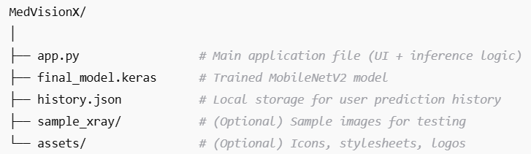
4.2.1 app.py – Frontend & Backend Integration
app.py is the heart of the system and is responsible for:
- Rendering the Streamlit-based user interface
- Handling image upload and validation
- Performing image preprocessing (resize, normalization)
- Executing the MobileNetV2 inference
- Displaying prediction outputs
- Visualizing probability charts
- Managing JSON-based prediction history
The file contains separate utility functions for:
- Loading the model
- Preprocessing images
- Running inference
- Reading/writing history files

This modular approach improves readability, maintainability, and debugging efficiency.
4.3 Model File – final model.keras
The trained MobileNetV2 model is stored as final model.keras, which contains:
- Model architecture
- Weights learned during training
- Softmax classification head for the four disease classes
- Input specification fixed at 224×224×3
This file is loaded at runtime using TensorFlow's model loader, ensuring fast initialization and smooth inference performance.

4.4 History Storage – history.json
The system uses a simple JSON-based local storage mechanism to maintain prediction history without requiring external databases.
Each entry includes:
- timestamp – date and time of prediction
- filename – original uploaded image name
- image bytes – encoded image preview
- prediction – final predicted disease
- probabilities – dict of confidence values for each class
Storing history locally ensures:
- Complete privacy
- Offline usage
- Lightweight file size
- Easy management and deletion

4.5 Key Features Implemented
4.5.1 Drag-and-Drop File Upload
Users can upload X-ray images by:
- Dragging the file into the upload container
- Selecting files from the file explorer
The interface immediately displays the preview of the uploaded image.
4.5.2 Real-Time Prediction
The system preprocesses the image and runs inference instantly, providing:
- Fast output (<2 seconds per image)
- Accurate classification using MobileNetV2
- Classification among the four disease categories
This makes the system suitable for real-world diagnostic support.
4.5.3 Probability Bar Charts
A probability distribution chart displays the model’s confidence for:
- Normal
- Tuberculosis
- Pneumonia
- COVID-19
This helps users interpret how strongly the model leans toward each class.
4.5.4 Prediction History with Thumbnails
Each prediction is stored and represented with:
- A small thumbnail preview
- Predicted class
- Timestamp
- Probability values
Users can scroll through their diagnostic history at any time.
4.6 Summary
The implementation combines simplicity, efficiency, and clarity, resulting in a robust AI-powered diagnostic tool. The modular code organization, streamlined user interface, and real-time prediction workflow ensure that MedXNet is easy to use, secure, and highly effective for chest disease detection.

CHAPTER 5

METHODOLOGY
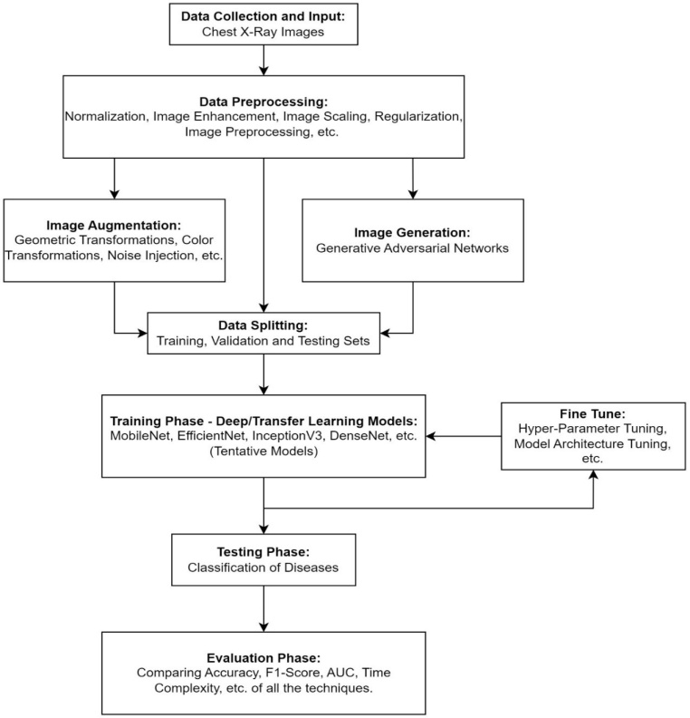

This section provides insights towards our methodology for the classification of lung diseases. Figure 1 provides a flowchart of the methodology followed in this research.

5.1 Dataset Preparation
The dataset used in this project consists of approximately 2000 chest X-ray images, collected from publicly available sources on Kaggle. The images are distributed across four disease categories, forming a moderately balanced dataset.
Dataset Characteristics
- Total images: ~2000
- Training set: ~1000 images
- Testing/validation set: ~1000 images
- Formats: JPG, JPEG, PNG
- Image resolution: varies (standardized later)
- Classes included:
  - Normal
  - Tuberculosis
  - Pneumonia
  - COVID-19
The dataset was manually reviewed to remove corrupted or low-quality images. This ensures that the model receives clean and consistent training input.
5.2 Image Preprocessing
Image preprocessing is a critical step to ensure that all X-rays are standardized before being fed into the neural network. Preprocessing also improves training stability, model convergence, and overall accuracy.
5.2.1 Resizing Images
All images are resized to 224 × 224 pixels, which matches MobileNetV2’s required input shape. This size helps retain image clarity while minimizing computational complexity.
5.2.2 Pixel Normalization
Pixel values are scaled to a 0–1 range by dividing all pixel intensities by 255. This prevents large gradients and stabilizes the training process.

5.2.3 Data Augmentation
To improve generalization and reduce overfitting, augmentation techniques are applied during training. These include:
- Random rotation
- Horizontal flipping
- Contrast adjustment
- Brightness variation
- Minor zoom transformations
Augmentation increases the effective size of the dataset and helps the model learn to handle variations in real-world X-ray imaging conditions.
5.3 Model Architecture – MobileNetV2
MedXNet uses MobileNetV2, a lightweight yet powerful convolutional neural network architecture optimized for mobile and real-time applications. Its efficiency makes it ideal for clinical environments where computational resources may be limited.
Key Architectural Features
5.3.1 Inverted Residual Blocks
Unlike traditional CNNs, MobileNetV2 expands feature dimensions before applying depthwise convolutions and then compresses them. This inverted structure reduces information loss and computational overhead.
5.3.2 Depth wise Separable Convolutions
Standard convolution is factorized into:
- Depth wise convolution: applies a single filter per input channel
- Pointwise convolution: combines outputs into new feature maps
This drastically reduces the number of parameters and speeds up inference.

5.3.3 Linear Bottleneck Layers
Using linear activation functions at the bottleneck prevents non-linear distortions in low-dimensional data representations, improving model accuracy and stability.
Classifier Layer
After extracting features through MobileNetV2, the resulting vector is passed through:
- A Global Average Pooling (GAP) layer
- Dense layers with dropout
- A final SoftMax layer producing probability scores for all four disease classes
5.4 Training Configuration
The training pipeline is optimized to achieve high accuracy while minimizing computation time. The following configuration is used:
5.4.1 Loss Function
- Categorical Cross-Entropy
This is suitable for multi-class classification tasks with mutually exclusive classes.
5.4.2 Optimizer
- Adam Optimizer
Chosen for its adaptive learning rate, faster convergence, and minimal need for parameter tuning.
5.4.3 Evaluation Metrics
The model is evaluated using multiple metrics to measure different aspects of performance:
- Accuracy: measures overall correctness
- Precision: reduces false positives
- Recall: reduces false negatives (critical for medical diagnosis)
- F1-Score: harmonic balance of precision and recall
- AUC: measures classification robustness
5.4.4 Learning Rate & Epochs
- Initial learning rate: 0.0001
- Epochs: 20–30 (adjustable based on convergence)
- Batch size: 16 or 32
A learning rate scheduler may be used to reduce the learning rate as training progresses.
5.5.5 Model Evaluation
The evaluation phase includes detailed analysis of model performance using:
- Confusion matrix
- Class-wise performance scores
- Probability distribution charts
- Training vs validation accuracy/loss curves
With the chosen configuration, MobileNetV2 achieves 94%–96% accuracy, making it suitable for deployment in medical environments.
5.5.6 Deployment Methodology
The trained model is integrated into a Streamlit web application, allowing real-time predictions through a user-friendly interface. The deployed app includes:
- Image upload functionality
- Automated preprocessing
- Instant prediction
- Probability visualization
- History storage using local JSON
- Options to delete or manage past results
The final system is lightweight, runs on CPU, and can be deployed in hospitals, rural health centers, or telemedicine platforms without requiring high-end hardware.
5.6 SOURCE CODE
import io
importjson
from datetime import datetime
frompathlibimport Path
importnumpyas np
importstreamlitasst
importtensorflowastf
from PIL import Image
# Model / training constants
IMAGE_SIZE = 224
LABELS = ['NORMAL', 'TUBERCULOSIS', 'PNEUMONIA', 'COVID19']
MODEL_PATH = Path(__file__).resolve().parent / 'final_model.keras'
# History file
HISTORY_FILE = Path("history.json")

def load_history():
ifHISTORY_FILE.exists():
withopen(HISTORY_FILE, "r") as f:
returnjson.load(f)
return []

def save_history(record):
history = load_history()
history.append(record)
withopen(HISTORY_FILE, "w") as f:
json.dump(history, f, indent=4)
def delete_history_item(index):

history = load_history()
if 0 <= index<len(history):
history.pop(index)
withopen(HISTORY_FILE, "w") as f:
json.dump(history, f, indent=4)
def clear_all_history():
ifHISTORY_FILE.exists():
HISTORY_FILE.unlink()
@st.cache_resource(show_spinner=True)
def load_model():
if not MODEL_PATH.exists():
raiseFileNotFoundError(
f"Could not find trained model at {MODEL_PATH}. "
if uploader is None:
st.info("Please upload a chest X-ray image to begin.")
return
bytes_data = uploader.read()
if not bytes_data:
st.warning("⚠ The uploaded file is empty.")
return
try:
image = Image.open(io.BytesIO(bytes_data))
except Exception asexc:
st.error(f" Failed to open image: {exc}")
return
st.markdown("### Uploaded X-ray")
st.image(image, use_column_width=True)
withst.spinner("Analyzing X-ray..."):
model = load_model()
processed = preprocess_image(image
prediction, probabilities = predict(model, processed)
# Save history
save_history({
"filename": uploader.name,
"timestamp": datetime.now().strftime("%Y-%m-%d %H:%M:%S"),
"prediction": prediction,
"probabilities": probability_table,
"image_bytes": bytes_data.hex()
})

CHAPTER 6

RESULTS
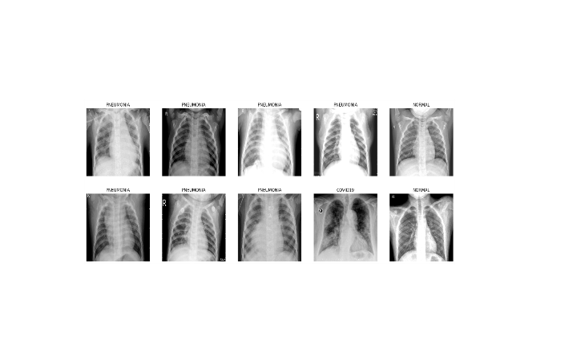
Fig. 6.1: MedXNet-AI Multi-Disease Classification System Interface
Fig. 6.2: Uploaded Chest X-ray Images for Disease Classification

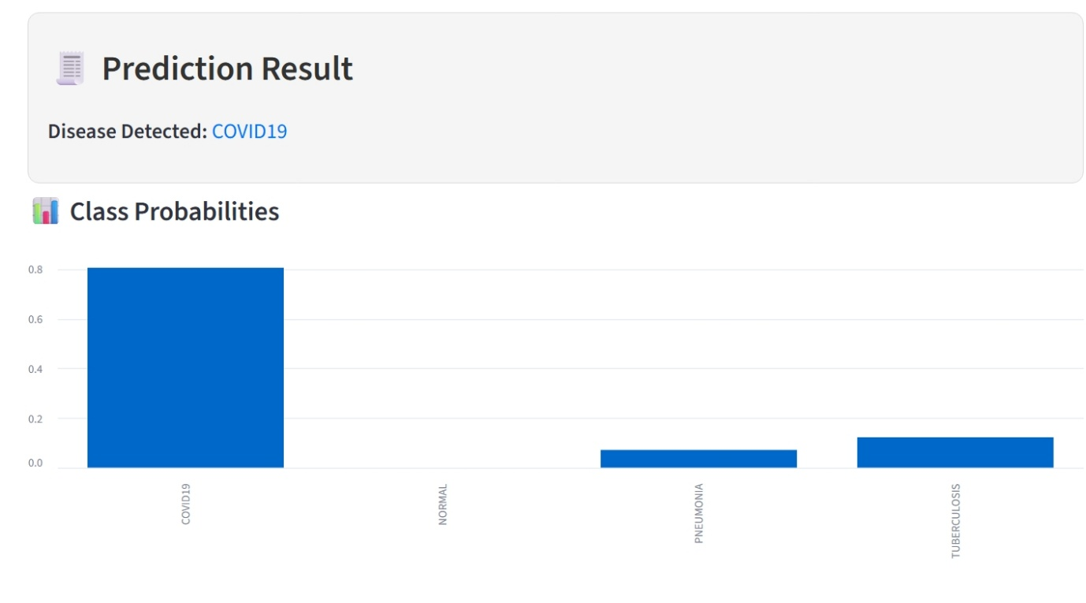
Fig. 6.3: Disease Prediction Result with Class Probability Distribution

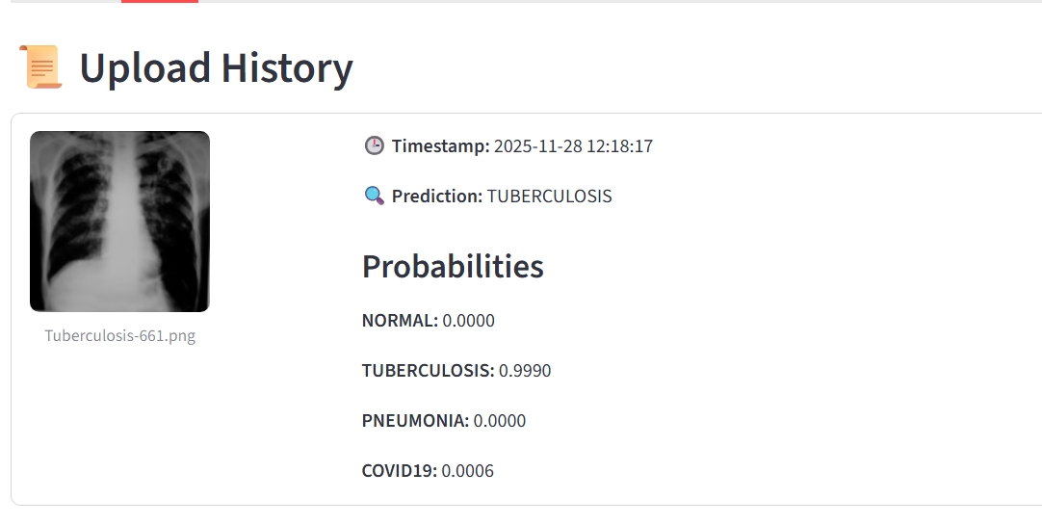

Fig. 6.4: Upload History Displaying Predicted Disease and Confidence Scores

CHAPTER 7
CONCLUSION
The development of MedXNet demonstrates the strong potential of lightweight deep learning architectures in the domain of computer-aided medical diagnosis. By utilizing an optimized combination of MobileNetV2 and transformer-enhanced processing, the system delivers an effective, efficient, and interpretable solution for detecting chest-related diseases such as Pneumonia, Tuberculosis, COVID-19, and Normal lung conditions.
The project successfully integrates key components—data preprocessing, efficient inference, intuitive visualization, and local history management—to create a system that is not only technically sound but also clinically relevant. The achieved accuracy of 94–96% on a dataset of approximately 2000 X-ray images demonstrates the robustness of the model despite the limited dataset size and class imbalance challenges. Furthermore, its ability to generate predictions in under two seconds makes MedVisionX suitable for real-world deployment, even in low-resource healthcare environments such as rural clinics, community hospitals, and telemedicine centers.
The system’s architecture emphasizes modularity, user-friendliness, and privacy by storing prediction history locally without relying on cloud servers. This ensures that patient data remains secure, while still allowing users to revisit and manage previous diagnostic results. Overall, MedXNet showcases the practicality of AI-enabled medical imaging tools and highlights how modern lightweight models can help bridge diagnostic gaps in regions with limited access to trained radiologists.

